**HL Unit 7** **– Control**  
Quiz 1

|  |  |  |  |
| --- | --- | --- | --- |
| **Question 1** | | | |
| Objectives: | 7.1.8 | Exam Reference: | May-14 10 |

1. Outline **two** distinct features of autonomous agents. [4]

*Award* ***[1 mark]*** *for a feature and* ***[1 mark]*** *for a description, for two features, up to*

***[4 marks max]****.*

*Feature:* Autonomy;

*Description:*

Agents *activate* alone for a task and are not invoked for a task;

Agents can *select the task* themselves (based on priorities or goal-directed search)

without human intervention;

*Feature:* Reactive behavior;

*Description:*

Agent senses the environment in which it is, and decides what to do reacting on its

perceptions;

*Feature:* Concurrency/sociality;

*Description:*

Agents can interact with other agents through communication, in different modes:

coordination, cooperation, competition;

*Feature:* Persistence;

*Description:*

The code describing an agent runs continuously like a process, and is not executed on

demand;

|  |  |  |  |
| --- | --- | --- | --- |
| **Question 2** | | | |
| Objectives: | 7.1.1, 7.1.3,7.1.4, 7.1.7 | Exam Reference: | Nov-14 15 |

1. A company uses computer controlled equipment to monitor and control a heating system. The user controls the system via an on/off switch and two dials that are used to set the maximum and minimum temperatures desired.

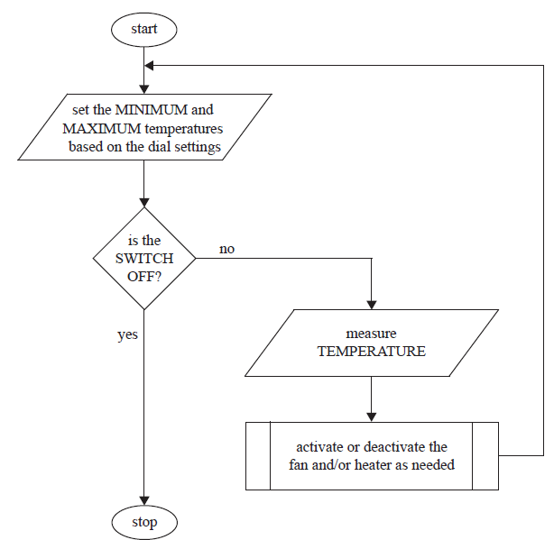The following flowchart represents the algorithm used to control temperature.

The temperature is constantly measured and the process of making the decision on   
which action to take is as follows.

If it is too cold (temperature is less than the minimum) then the heater should be  
switched on. If it is too hot (temperature is greater than the maximum) then the   
fan should be switched on. If temperature is within the given range (temperature  
greater than the minimum and less than the maximum) then both the fan and heater  
should be switched off.

1. Identify **one** situation in which the system should respond to
2. input from a user; [1]

*Award* ***[1 mark]*** *for identifying a user input.*

Min and max temperature;

System on or off;

1. temperature. [1]

*Award* ***[1 mark]*** *for identifying one of the situations.*

When the temperature is above the max;

When the temperature is below the min;

When the temperature is between the max and the min;

1. State three hardware devices that are needed to capture the input data and   
   produce the system outputs. [3]

*Award* ***[1 mark]*** *for each hardware device identified up to* ***[3 marks max]****.*

Sensors;

Transducers;

AD converters;

Actuators;

Heater;

Fan;

1. Construct pseudocode for the algorithm outlined on the previous page. [4]

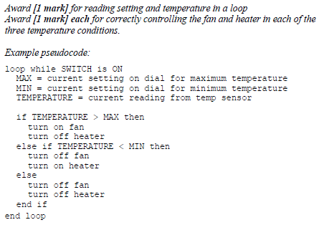

1. The company wants to use its heating system to control the temperature of ten   
   different places at the same time. All ten places will have the same maximum and  
   minimum temperatures and each will have its own heater, fan, and temperature  
   sensor. Evaluate the decision of having all ten temperature sensors, fans, and heaters  
   connected to a single control computer instead of having ten separate heating systems. [6]

*Award marks as follows up to* ***[6 marks max]****.*

*Award* ***[1 mark]*** *for each advantage identified, up to* ***[2 marks max]****.*

*Award* ***[1 mark]*** *for each disadvantage identified, up to* ***[2 marks max]****.*

*Award* ***[1 mark]*** *for a contrast of the identified advantages and disadvantages.*

*Award* ***[1 mark]*** *if the contrast is clear, and explains the relevance of the advantages and disadvantages.*

*Possible advantages include:*

Only need a single set of max/min dials and only one on/off switch.

There is no way for the locations to accidently have different settings.

All ten locations can be controlled from a single place so you don’t have to run around to each one.

All the temperature data is available in one place, which may make recording and analyzing it easier.

*Possible disadvantages include:*

May need a lot of wires to connect all the locations to the control computer.

If the control computer breaks, all the locations suffer.

The software will have to be changed.

|  |  |  |  |
| --- | --- | --- | --- |
| **Question 3** | | | |
| Objectives: | 7.1.1, 7.1.2, 7.1.3 | Exam Reference: | May-14 11 |

A builder is renovating a series of apartments and is considering integrating a few electrical  
devices in each apartment into an automatic programmable system. One example is the  
integration of lighting, heating, ventilation and air conditioning.

1. Identify **two** groups of users that might find this integrated technology

particularly appealing. [2]

*Award up to* ***[2 marks max]****.*

Elderly;

Disabled;

Commuters;

*Accept other reasonable answers.*

1. Discuss **two** advantages, offered by this technology, that could be used in an advertisement for the apartments. [4]

*Award* ***[1 mark]*** *for advantage and* ***[1 mark]*** *for explanation, for two items, up to*

***[4 marks max]****.*

Improved convenience;

One can better control times of functioning, hence costs;

Improved comfort;

One can program the functions according to their specific needs;

Energy efficiency;

One can program/plan the functions based on the surrounding environment and

reduce energy waste (interconnected systems);

Safety;

Programmed in a way to avoid electric overload and faults;

*Accept other reasonable answers*

1. Evaluate **two** ways users can access the functionality of the integrated system   
   at home. [6]

*Award up to* ***[6 marks max]****.*

*Award up to* ***[3 marks max]*** *for each of the two ways.*

*Award* ***[1 mark]*** *for the way of access and up to* ***[2 marks]*** *for two additional*

*points, which could be advantages or disadvantages.*

*Examples include fixed/non-fixed installations, digital/analogue.*

Computer based/TV-based control;

The user always knows where the control is;

Because the device may not be portable;

Inconvenient if computer/TV already being used by someone else;

Touch screen/keypads in fixed installation;

Ergonomic gadget/small dimensions/cheap device;

Wide range of different designs to fit different locations in a house;

Difficult to lose;

Inconvenient to operate some devices by having to go to a fixed panel/not suitable for

extended use to operate TVs etc;

Smartphone;

Portable/useful for some groups of users (limited mobility);

Can be easily extended to include other devices;

Could be lost or misplaced;

Requires internet/Wi-Fi/signal to operate;

*Accept other suitable answers.*

The same technology is adapted and used for intensive chicken farming; in this context a  
 decentralized control is preferred.

1. Describe how this could be achieved. [3]

*Award up to* ***[3 marks max]****.*

Transmission: integrated wiring or internet or wireless;

Requires: extended/dedicated network and hw/sw for protocols/transmissions and

sensors/actuators;

Use: The farmer can vary the parameters/environmental conditions from home at

any time and better concentrate on other activities (*eg* trade with KFC);